Some Example for checking pupose:-

1. Input :-

Dear Students,

We invite you to actively join us in a noble cause at our upcoming Blood Donation Camp, organized as part of Revelation 4.0 (The Annual Tech Fest of the Department of Computer Science and Technology). This initiative is more than just an event—it is a call to stand together and make a real difference in our community.

Why Your Involvement Matters:

• Save Lives: Every unit of blood donated can bring hope and healing to someone in need.

• Social Responsibility: By joining this effort, you are embracing the spirit of community and solidarity.

• Empower Change: Your participation sends a strong message that as students, we are committed to positively impacting society.

Event Details:

Date: March 21, 2025

Time: 11:00 AM

Venue: [Amenities ]

Let’s unite to save lives and create a lasting impact through this social cause. We look forward to your enthusiastic response and support.

**Output:-**

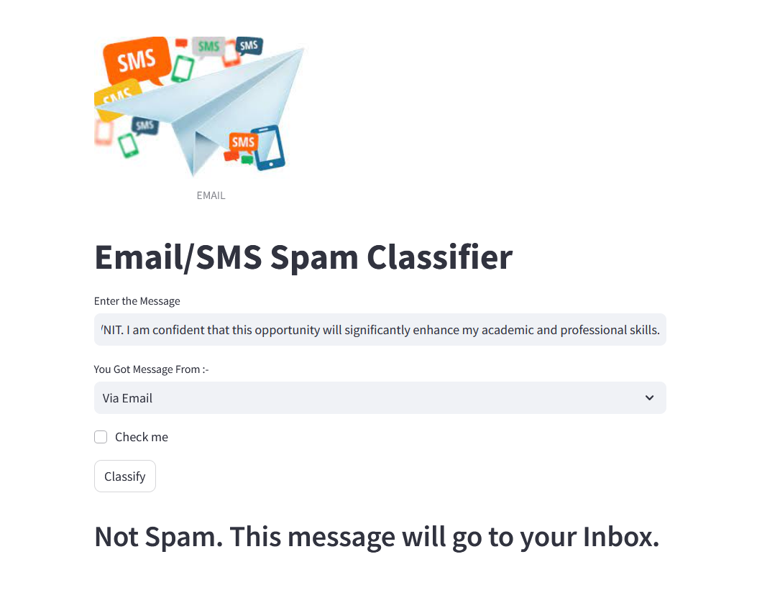

1. Input :-

Free entry in 2 a wkly comp to win FA Cup final tkts 21st May 2005. Text FA to 87121 to receive entry question(std txt rate)T&C's apply 08452810075over18's

**Output:-**

